ABSTRACT

In the recent years Object detection and its application have become a part of our daily life. Now days most application around us use object detection technique. It is not only used for surveillance and security but also is been used for traffic checking, recognizing speeding car number plate, tracking the ball in sports match (cricket, football) and even been used for counting people.

Object detection is a computer vision technique which is used to identify object in images, videos and in real time also. Its goal is to identify a given set of objects or its instances in an image or a video by producing boundaries or bounding boxes around the object.

Object detection is a basic yet a challenging problem in the filed of computer vision as it works with both object localization and classification within a video or an image.

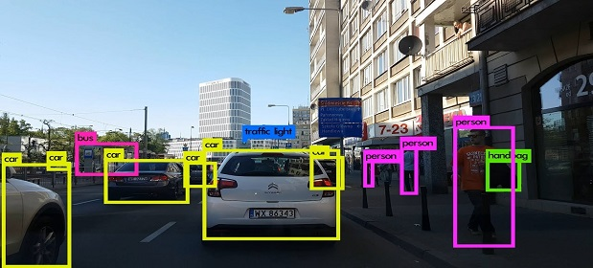

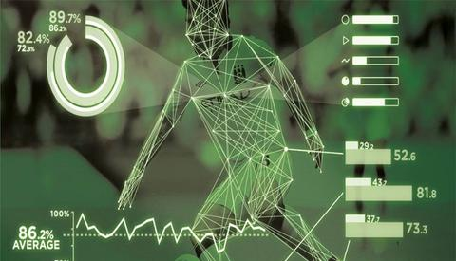INTRODUCTION

Object detection is a process in which objects like humans, cars or any given object can be detected as objects in images, videos or real time. It is a very important technology of deep learning. It recognizes objects and surround them with bounding box and then label each box with the object name. While it is easy for humans to detect object but machines and computer cannot recognize object by their self. They use object detection technique or models to detect object in images or real time videos. It is very important part and fundamental part of computer vision.

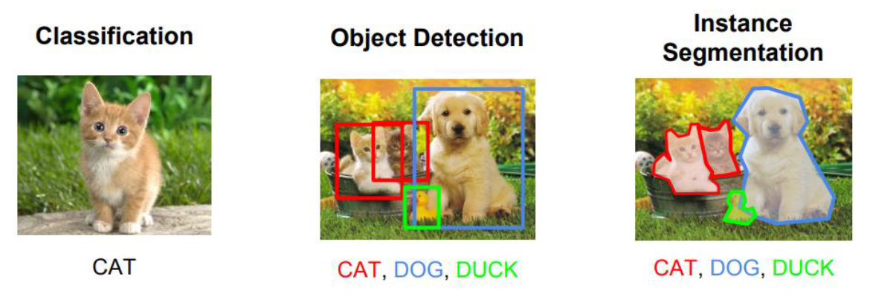

Object detection is mostly misinterpreted with image recognition. While image recognition is a process in which an image is labeled as the object name. If there are more than one object in an image it will still label the image as the name of first object. While on the other hand object detection will recognize both the objects and make a bounding box around the objects and label those boxes with the name of the object.

Example- In image recognition an image of Cat is labelled as a ‘Cat’ but in object detection both a ‘Cat’ and a ‘Dog’ will get recognized and box is made around the object which will be labelled as ‘Dog’ and ‘Cat’ respectively.

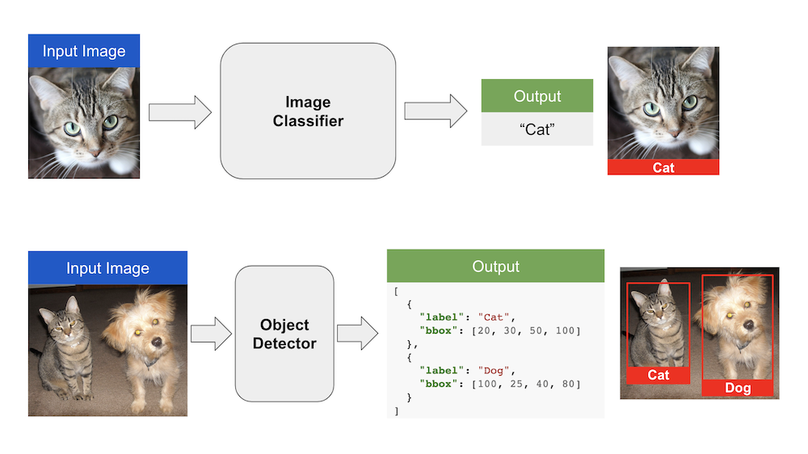

Machine learning approach for object detection

There are machine learning techniques that are utilized to detect an object inside images and these techniques are manually executed algorithms, consequently they are not learned systems.

Algorithms such as Histograms of Oriented Gradients (HOG)/ Scale Invariant Feature transformation (SIFT) were introduced around 2005 and uses normalized local histograms of image gradients to identify interest points inside images.

The technique depends on the instinct that an object of interest has an unmistakable arrangement of qualities that can be distinguished by the local intensity of gradients and edge course on a for every window premise. Finally, it gives a HOG descriptor which is affine invariant and implemented in a detection chain that develops a Support vector machine (SVM) which detect objects of interest-based on the HOG descriptors.

Machine learning techniques for object detection

1. Scale Invariant Feature Transform (SIFT) –

Object which needs to be detected must have a unique method to allow identification

across real time videos and images. This method is used for obtaining objects fingerprint

in a video or an image.

SIFT algorithm capture and identifies the information on local points of features inside an image and identifies the object in the image based on the extracted feature.

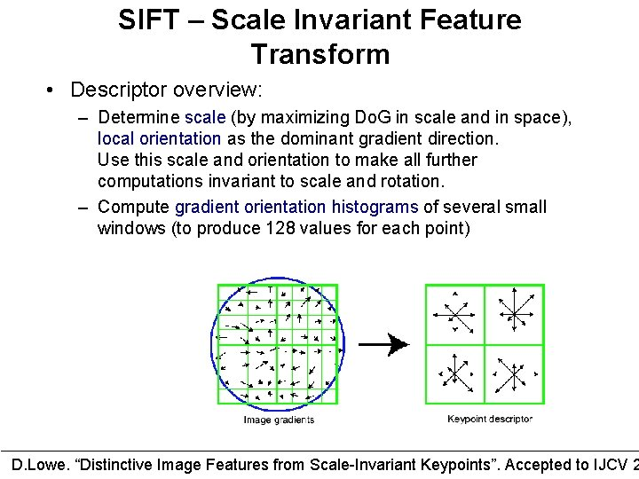

1. Object Detection based on Haar features-

Haar are identifiers inside an object that can be used for object recognition and detection.

Qualities of a segment of an image can be caught by putting contrasting the pixel forces of two adjoining rectangular locales and discovering the distinction between the summation. The aftereffect of the thing that matters is basically our descriptor for that specific segment of the image.

In real world situation, Haar can be utilized inside face detection. There are fluctuations of pixel powers across the human face, for instance, the eyes. The eye district has a more obscure shade in contrast with adjoining regions

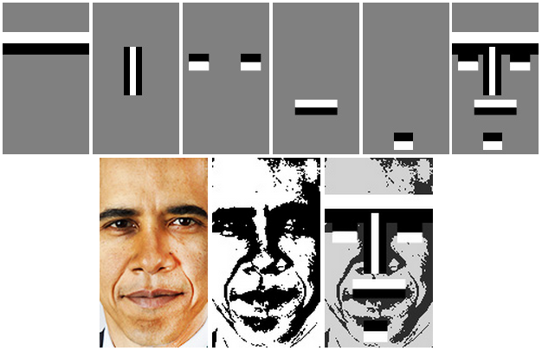

Deep learning approach for object detection

There are two main approaches while using deep learning technique for object detection, the first method is to train and design a network architecture from scratch, including the design of layers and the initialization of weight parameter values. The second method is to use the concept of Transfer learning and using

a pre-trained network that’s trained on a big dataset.

The second method is much faster than the first method and reduces time significantly.

Convolutional Neural Networks (CNN) models for Object Detection

1. Region-Based Convolutional Neural Networks (RCNN) And Its Variants

It is a method based on deep learning, used for object detection and segmentation. It was first introduced in the mid of 2014 and introduced the concept of region-based convolutional neural networks (RCNN)

RCNN uses specific search algorithms to a given region of interest in a video or an image and thereafter after uses CNN to detect the given object in an image.

It uses CNN for feature extraction and utilizes binary SVM for classification of objects. As it does not use any manual technique therefore it is not simple learnable solution.

It is takes around 40-50 seconds to complete its predictions on a video or an image. Some new version of RCNN is fast-RCNN and faster-RCNN which has better performance and efficiency than RCNN. RCNN cannot be used for real time detection as it takes a lot of time to complete its predictions.

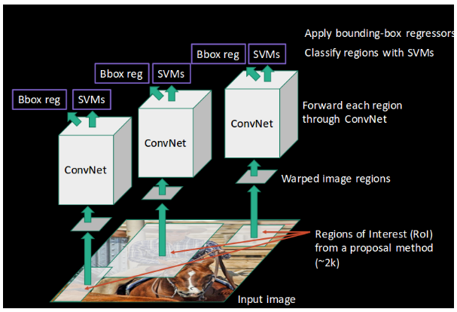

1. YOLO (You Only look once)

YOLO is neural network model in which an image is passed just once through its network to conduct object detection and hence it is a one-step process unlike RCNN which is a two-step process. It has a greater efficiency than the RCNNs model and hence can be used for detection in real time.

YOLO places a grid over the image, in which each cell/grid plays two roles-

* Every cell/grid predicts bounding boxes and a value is assigned to each grid or bounding box. The value around each box represents the probability that the cell/grid contains an object or not.
* Every cell/grid also gives a classification probability result which represent the chance that if a grid contains an object or not.

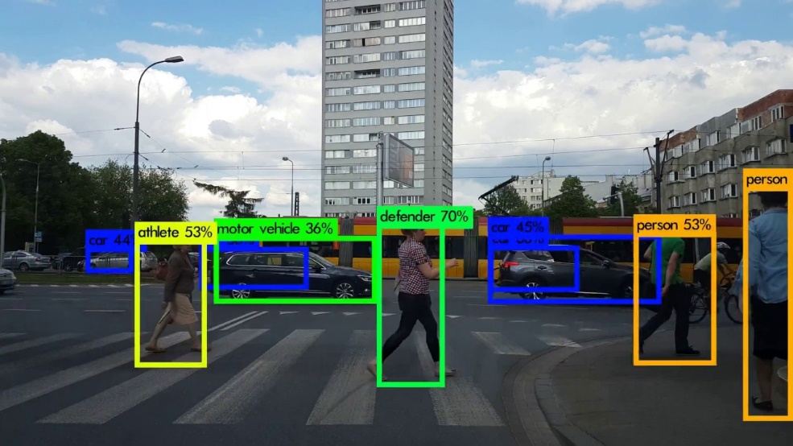

Application of object detections

1. Automated CCTV surveillance-

From the past few years object detection technique are been used in CCTV or surveillance camera. Through object detection weapons like guns, knives can be easy detected and reported with the help of the CCTV camera. This application is still not prefect but many companies and start-ups are working to improve the application.

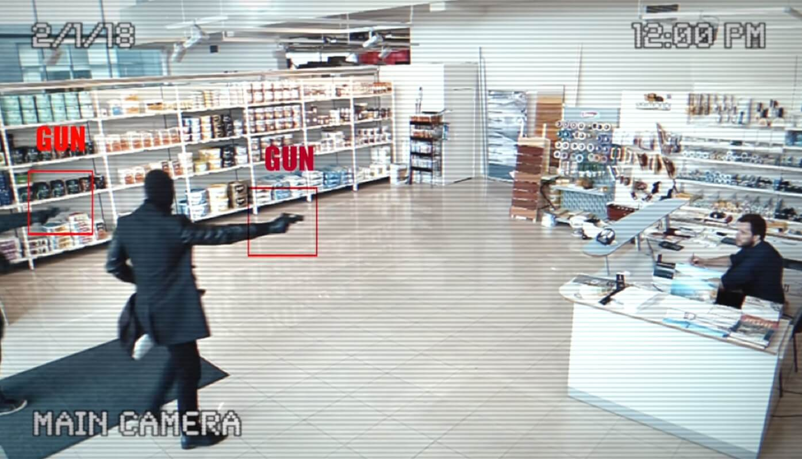

1. Self-driving cars-

Object detection technique is highly used in self driving cars like Tesla etc. With the help of cameras, radar and lasers self-driving cars get information about its surrounding, then use Image Classification, Object Localization and object detection models to detect object around its surrounding.



1. Crowd counting-

Another important application of object detection is crowd counting. With the help of object detection, business can measure different kinds of traffic which could help them to optimize logistics pipelines and inventory management. This could also help state government and municipalities to plan events in the cities and states more efficiently.

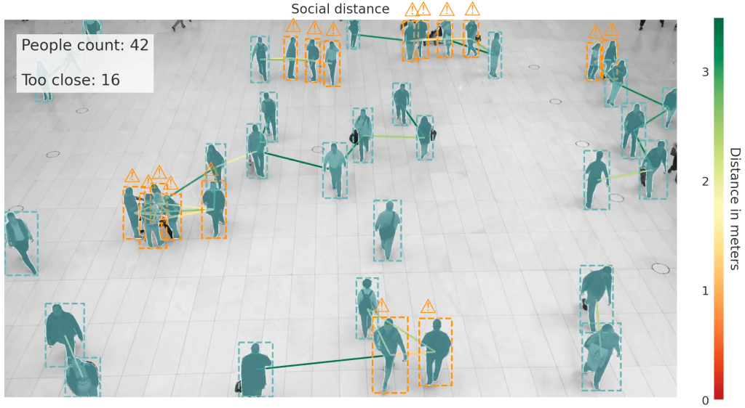

1. Anomaly detection-

Object detection can also be used in detection anomaly in various industry. For example, it can be used to detect infected crops in agriculture, skin related problems in healthcare and can also detect defects parts in manufacturing industries.

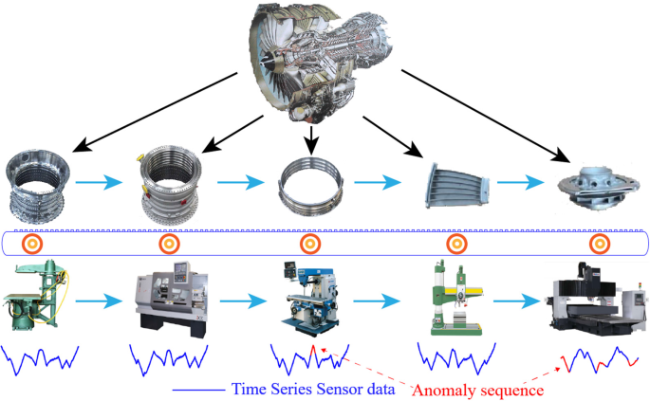

History of object detection-

Computer vision, object detection and other AI technique has become highly advanced technology but they still struggle to match the human perception.

Object detection is a way to recognize unknown objects in an image or in real time video.

There are two types of object detection -:

* + Machine learning or traditional object detection
  + Deep learning object detection

Machine learning or traditional object detection

In early period of object detection, most of the algorithms for it was based on fixed feature which was given by humans.

Some early models of Machine learning object detection were

* Viola Jones Detectors

This model of object detection was developed by Paul Viola and Michael Jones in the year 2001. This model was used to detect human faces in real time video. This model used the technique of sliding windows which searches for “Haar-Like” features to analyze all location and scale in video and images to check whether a window contain a human face or not.

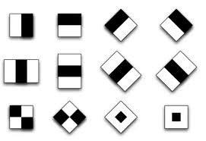

* Hog Detector-

This object detection model was developed by N. Dalal and B. Triggs in 2005. This model uses blocks technique which captures a pixel grid in which gradients are made up of magnitude and direction of change in intensities of pixel in a block. It is highly used for pedestrian detection.

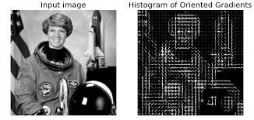

* Deformable Part-based Model (DPM)-

This model was first developed in 2008 by P. Felzenszwalb and later it was improved by R. Girshick. This model was just an extended version of Hog detector. This model was used to detect car in real time and used the strategy of divide and conquer. It detects body, window, and wheels separately in an image. DPM model used a root filter and part filter to detect object. To increase it’s accuracy techniques like hard negative mining, bounding box regression, and context priming were used.

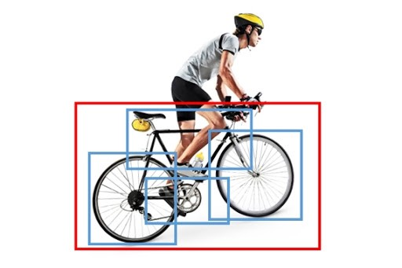

Deep learning object detection

By the end of 2010 machine learning object detection performance got saturated. To increases efficiency of object detection a new method of object detection was introduced by the end of 2012 which used convolutional neural networks and deep convolutional networks. By the end of 2014 RCNN model for object detection was made.

Some models of Deep learning object detection are

* RCNN

It begins with the extraction of a bunch of object proposals by specific search. Then every proposition is rescaled to a fixed size picture and took care of into a pre-prepared CNN model to extract features. To predict the presence of an object within each area and to recognize object categories linear SVM classifiers were used. This model was better than Machine learning models but still had its drawbacks.

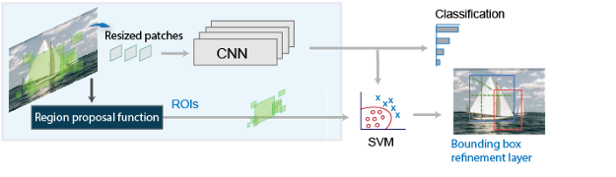

* SPPNet (Spatial Pyramid Pooling Networks)

This model was proposed by K. He et al in 2014. There is single pooling layer or no pooling layer at the transition of convolution layer and fully connected layer. This model proposes to have multiple pooling layers of different scales.

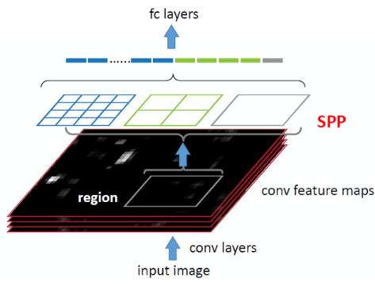

* Fast RCNN:

It uses the whole image for CNN input to get all the features unlike RCNN which takes features from proposed regions. It uses selective search , which is applied on the picture and assume it produces n proposed areas, their various shapes show districts of interests (RoIs) of various shapes. Quick R-CNN presents RoI pooling, which utilizes the CNN yield and RoIs as contribution to yield a link of the highlights extricated from each proposed locale and took care of into a completely associated layer During classification forecast, the state of the completely associated layer yield is again changed to n×q and we use softmax relapse (q is the quantity of classes and n is the quantity of proposed areas). During jumping box expectation, the state of the completely associated layer yield is again changed to n×4. This implies that we foresee the class and jumping box for each proposed area.

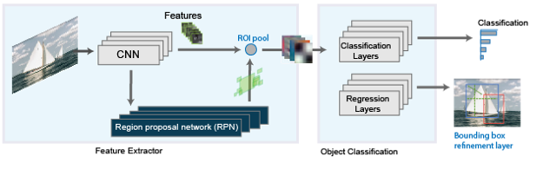

Working project on object detection using python

* Library and software used-:

1. Open Cv module
2. TensorFlow module
3. Lxml image labelling software
4. OS module
5. Wget module
6. object_detection module
7. NumPy
8. Matplotlib

* Model used – In my project I used SSD MobileNet V2 FPNLite 320x320 from TensorFlow 2 Detection Model Zoo. This model has speed of 22ms and COCO of 22mAp. It detects an object and a box around it with precision value.
* My project-
  + I started collection images for my training and testing data set using Open CV

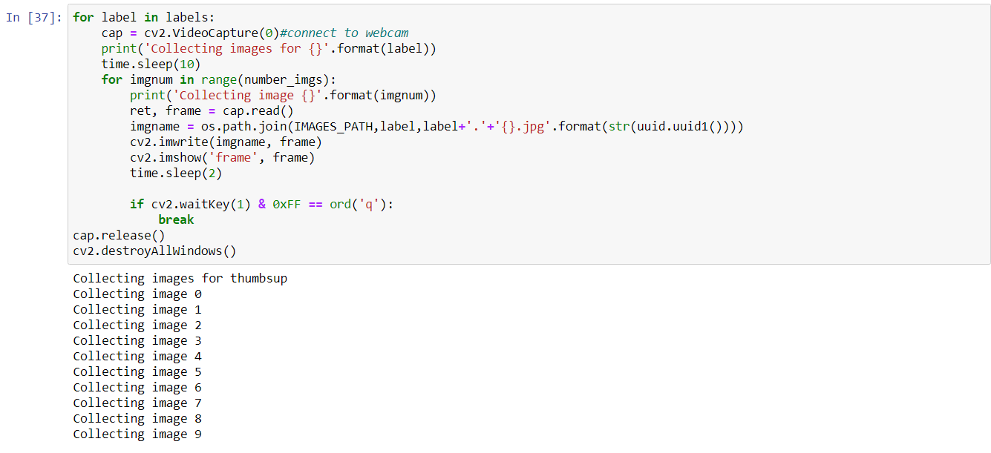

* + After that I label my images using labelimg.py

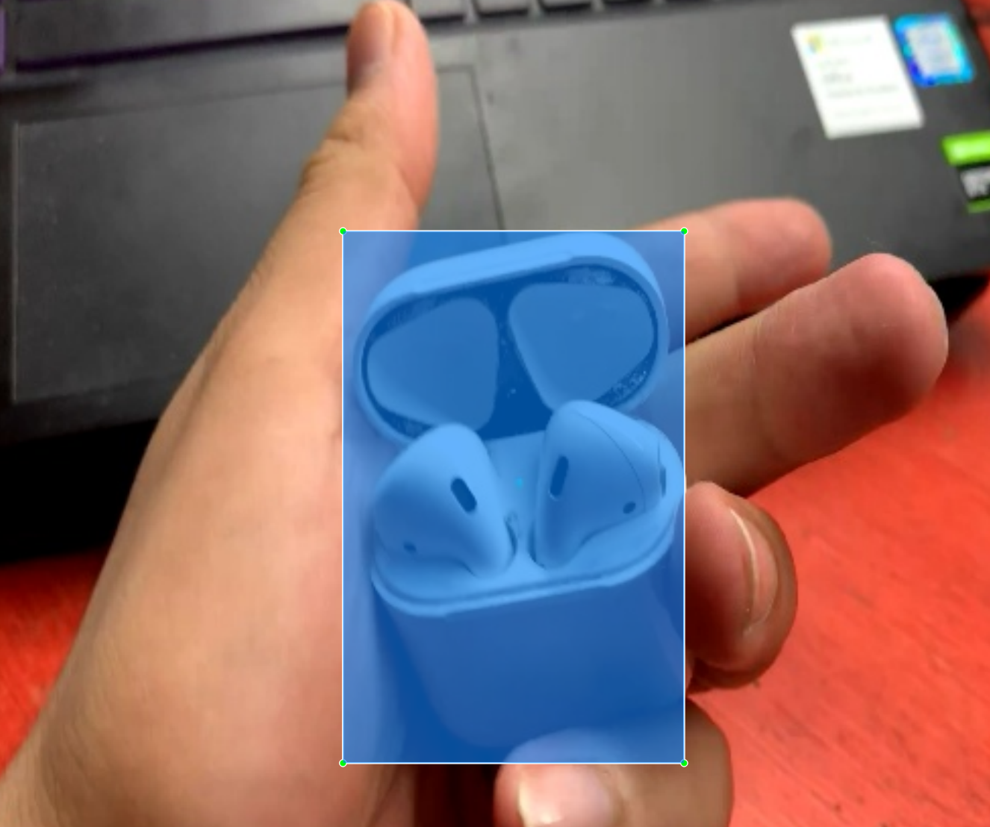

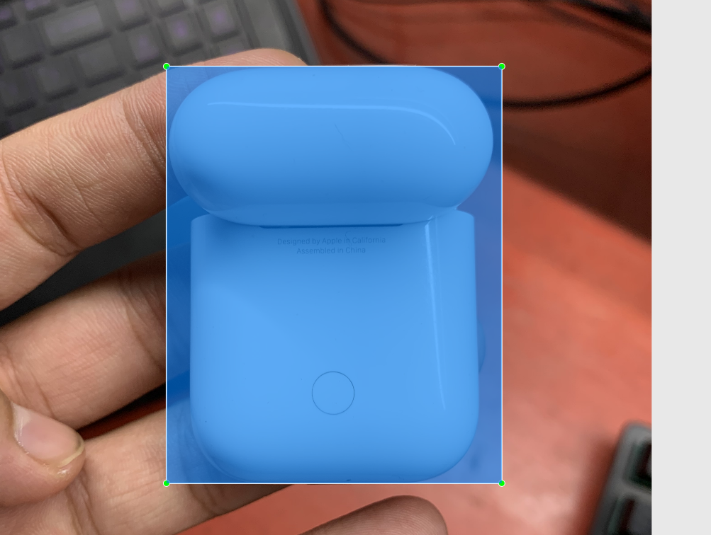

* + After that I setup paths and install SSD MobileNet V2 FPNLite 320x320 from TensorFlow 2 Detection Model Zoo.

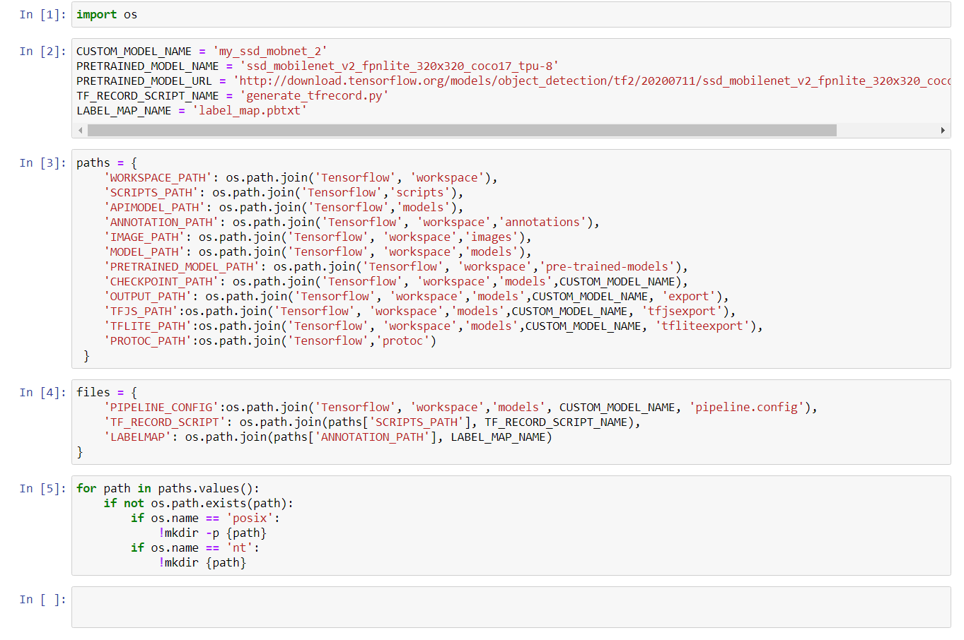

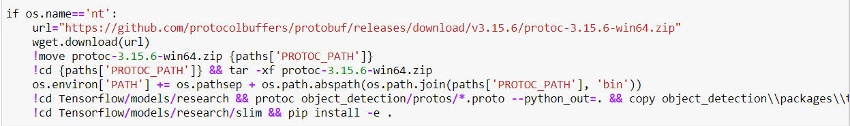

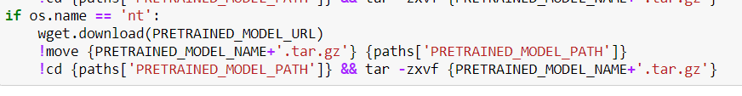

* + Then after created my labels and using transfer learning updated the object detection model for my custom object detection.

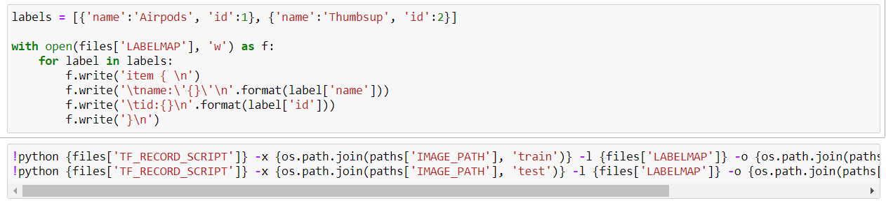

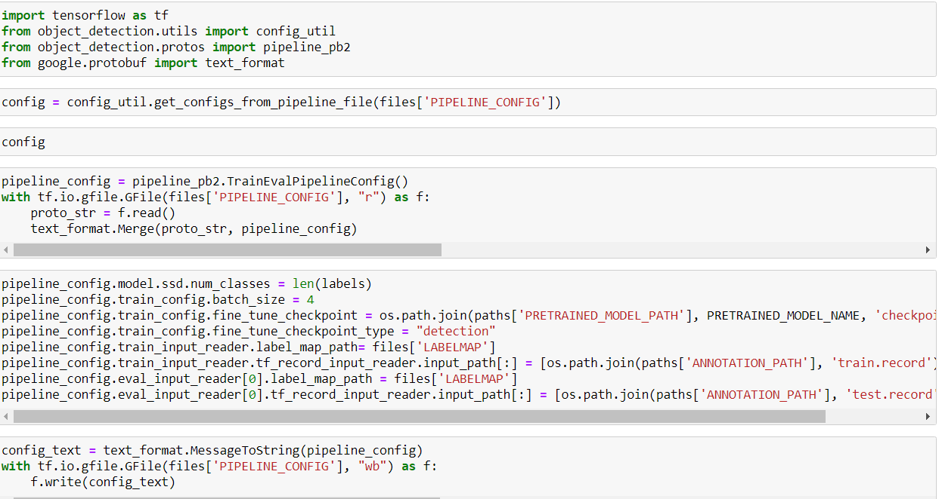

* + Once this was done, I finally trained and evaluated my model for my custom object.

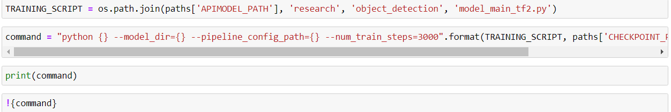

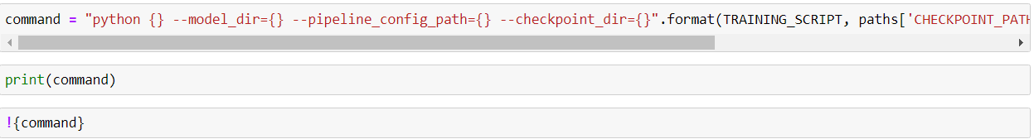

* + Finally, I tested my model with a testing image and the object got detected with a good precision value.

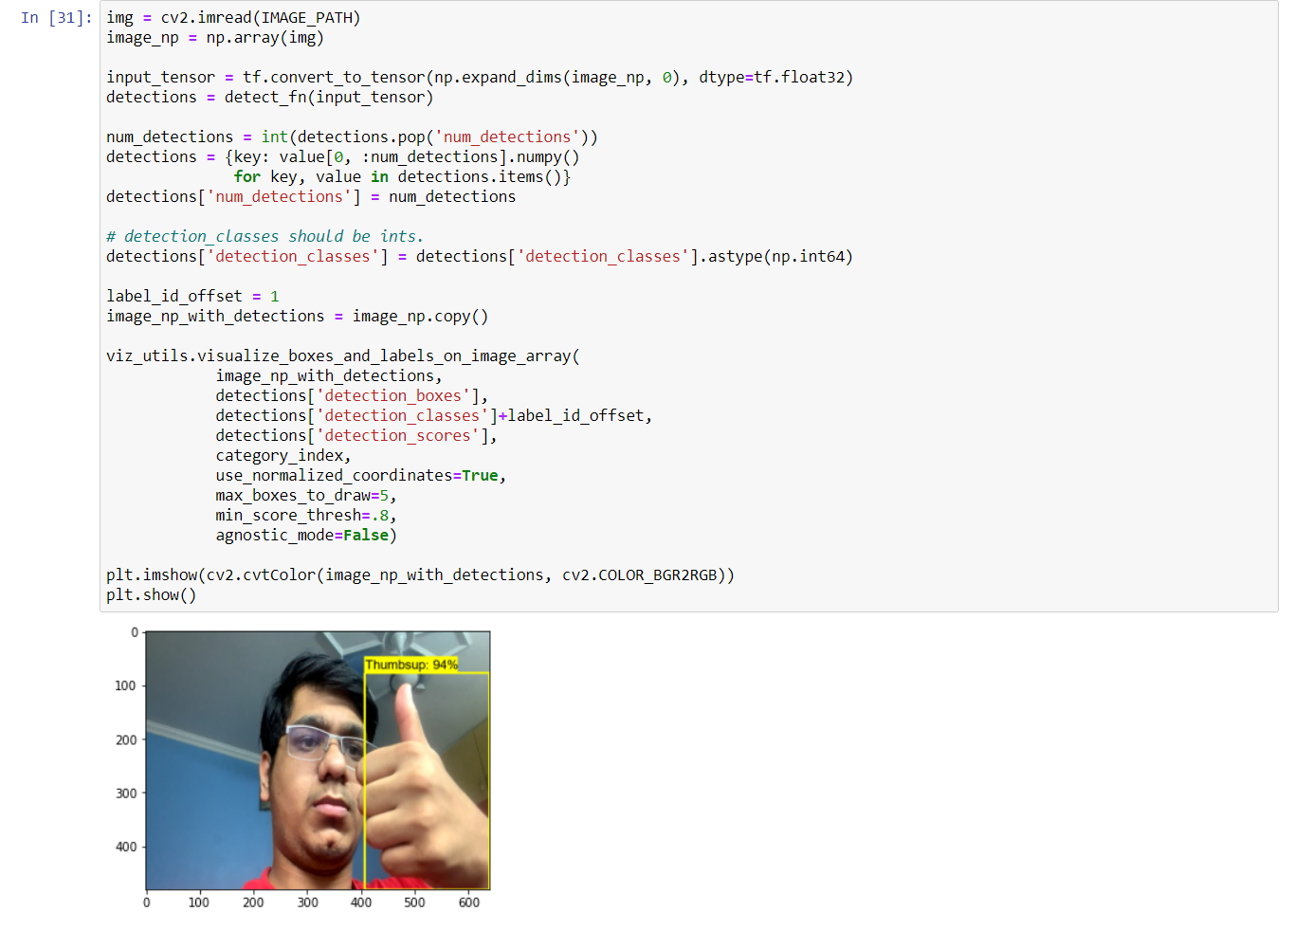

* + Then I did some real time detection using Open CV module and the result were quite good.

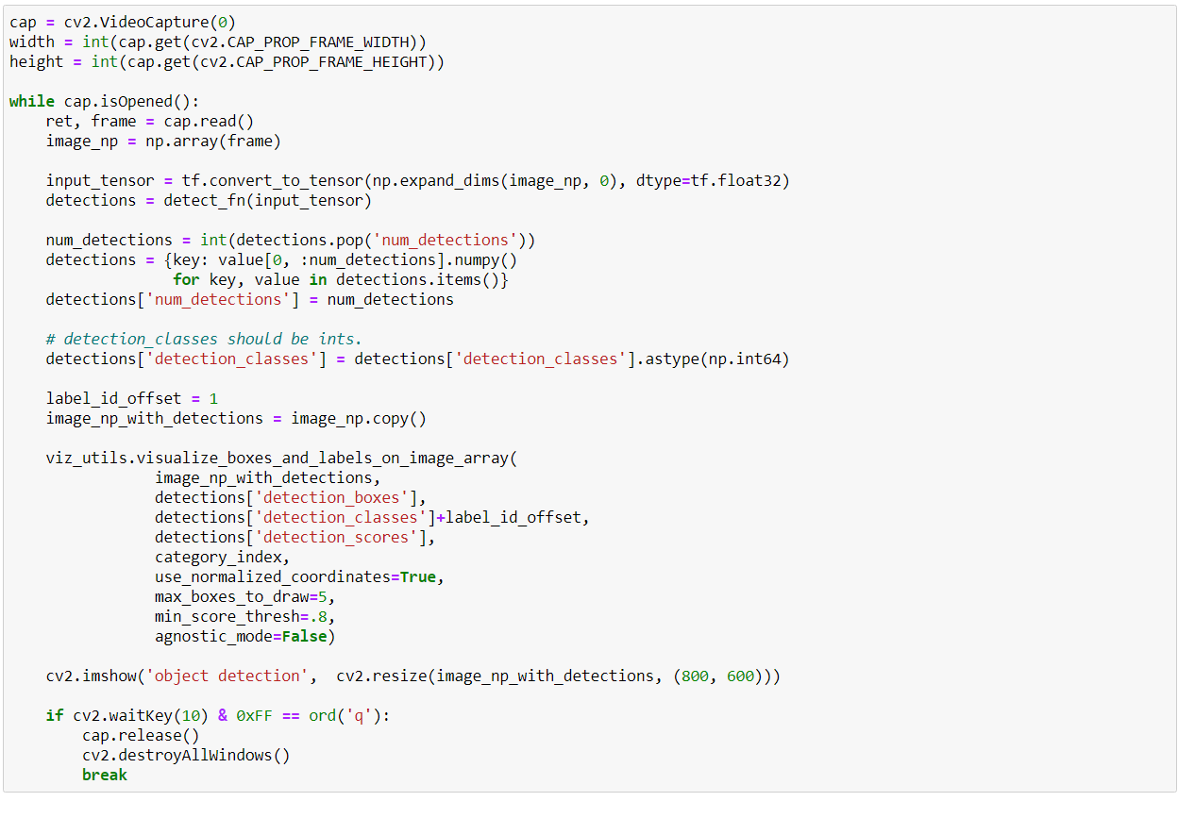

* + Real time object detection result-:

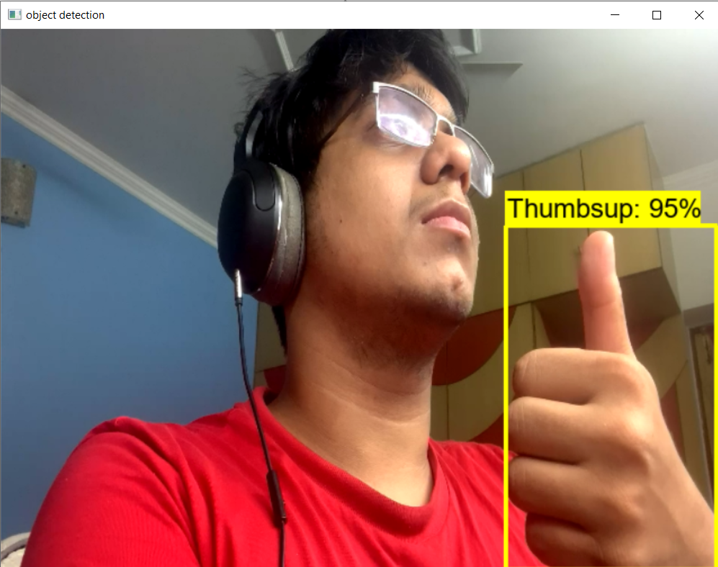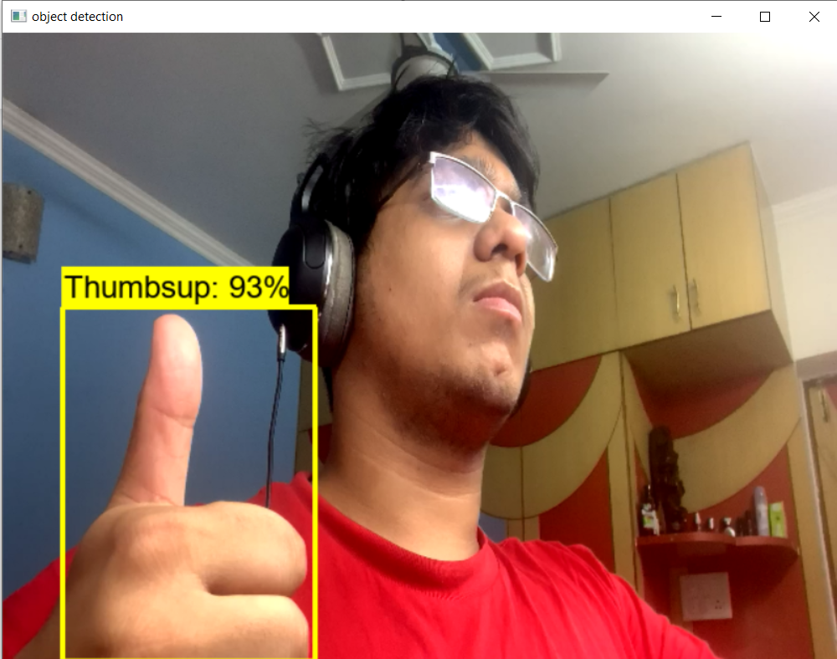

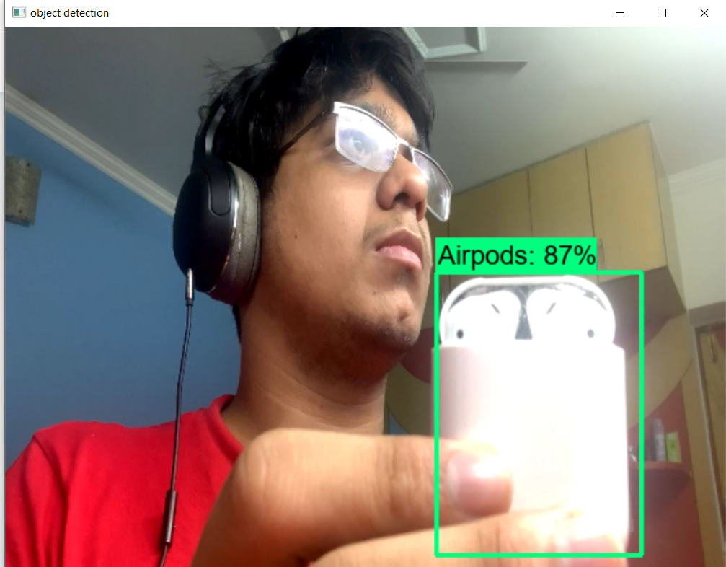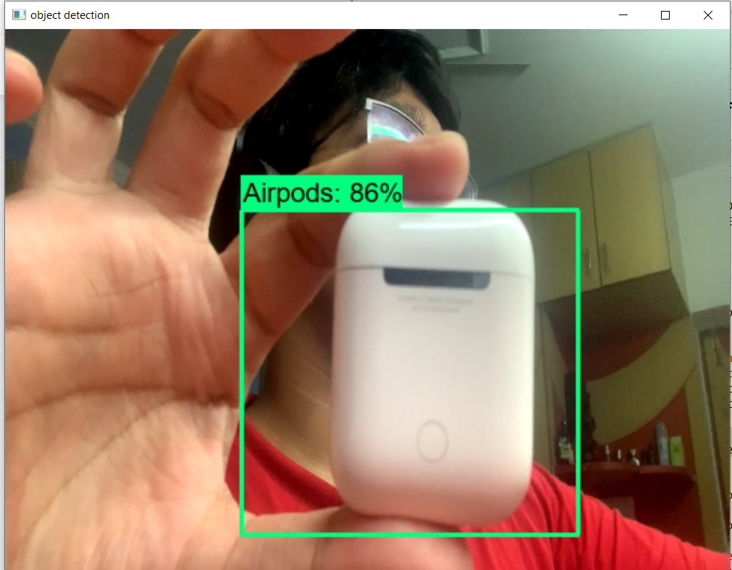

Conclusion

Over the past 20 years object detection technology has grown significantly and many improvements has been made on this and still more advancement will happen over time.

The effort made here is, the small step which can be further explored in the real-life applications like self-driving cars and automated CCTV by utilizing the high-end cameras and sensors.

The future advancements in the areas like Detection meets AutoML, Detection meets domain adaptation, Detection in videos, Lightweight object detection will help to grow this area.